Title of Paper for 13th ISHPMIE
First Author ^{a,b}, Second Author ^{b} & Third Author ª
ª First affiliation (organization, city, country)
^{b} Second affiliation (organization, city, country)
E-mail: corresponding@author.com
Abstract
A concise and factual abstract is required. The abstract should state briefly the purpose of the research, the principal results and major conclusions. The abstract is often presented separately from the article, so it must be able to stand alone. For this reason, please avoid references and non-standard or uncommon abbreviations in the abstract. The abstract should use the predefined font, be contained within one single paragraph, and the number of characters should not exceed 2000.
Keywords: prevention, mitigation, industrial explosions, …

- Introduction
State the objectives of the work and provide an adequate background, avoiding a detailed literature survey or a summary of the results. Divide your article into clearly defined and numbered sections. Subsections should be numbered 1.1 (then 1.1.1, 1.1.2, ...), 1.2, etc. Use this numbering also for internal cross-referencing: do not just refer to 'the text'. Sections such as Abstract, Acknowledgements and References are not included in section numbering.
References must follow the ‘Author (year)’ format. This section and the list of references illustrate the format: ‘Eckhoff (2003) describes agglomeration of dust particles in the dust cloud (Boilard et al., 2013)’.
- Experiments
Provide sufficient detail to allow the work to be reproduced. Methods already published should be indicated by references: only relevant modifications should be described.
2.1 Experiments with propane-air mixtures
This section describes …
2.1.1 Initially quiescent conditions
This section describes …
2.1.2 Initially turbulent conditions
This section describes …
2.2 Dust explosion experiments
This section describes …
- Results and discussion
Results should be clear and concise. This should explore the significance of the results of the work, not repeat them. A combined Results and Discussion section is often appropriate. Avoid extensive citations and discussion of published literature.
3.1 Figures and figure captions
Ensure that each illustration has a caption. Figure captions should be placed below the figures, and table captions above the tables. A caption should ideally comprise a brief title and a description of the illustration.
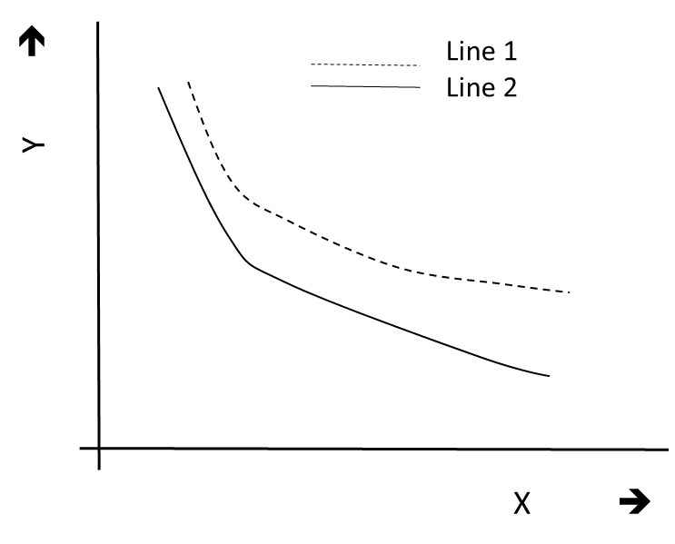
Fig. 1. The dependence of Y on X for stages 1 and 2

The caption should normally be centred (like above), but in the event that your caption covers several lines you may also use the format described for Figure 2 below.
Fig. 2. Example of a figure caption that covers more than one line, in which case it is recommended to use justified text. The same principle would apply to table captions

3.2 Tables and table captions
Number tables consecutively in accordance with their appearance in the text. The numbers should not include the number of the section (or chapter). Place footnotes to tables immediately below the table body and indicate them with superscript lowercase letters. Be sparing in the use of tables and ensure that the data presented in tables do not duplicate results described elsewhere in the article.

Table 1: Selected seminars related to industrial explosions
Event | Dates | Venue
13th International Symposium on Hazards, Prevention, and Mitigation of Industrial Explosions | 27-31 July | Braunschweig, Germany
11th International Symposium on Hazards, Prevention, and Mitigation of Industrial Explosions | 24-29 July | Dalian, China

- Conclusions
Briefly summarize the main conclusions of the study.
Acknowledgements
The authors gratefully acknowledge the financial contribution from …

References
Boilard, S.P., Amyotte, P.R., Khan, F.I., Dastidar, A.G. & Eckhoff, R.K. (2013). Explosibility of micron- and nano-size titanium powders. Journal of Loss Prevention in the Process Industries, 26(6): 1646-1654.
Eckhoff, R.K. (2003). Dust explosions in the process industries. Third edition. Gulf Professional Publishing, Amsterdam.

